**Module-8: Jenkins Assignment - 2**

You have been asked to:

● Add 2 nodes to Jenkins master

● Create 2 jobs with the following jobs:

○ Push to test

○ Push to prod

● Once a push is made to test branch copy git files to test server

● Once a push is made to master branch copy git files to prod server

Created Slave2

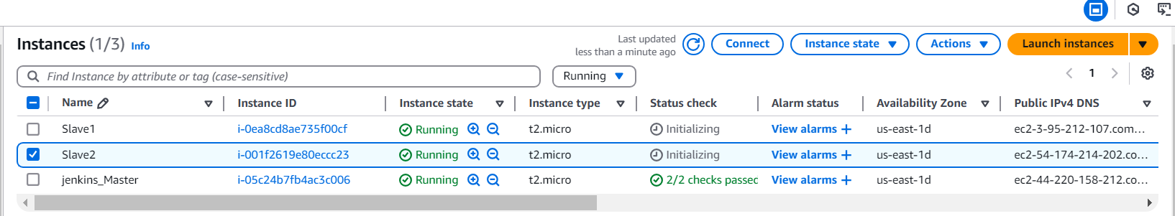

Create node2

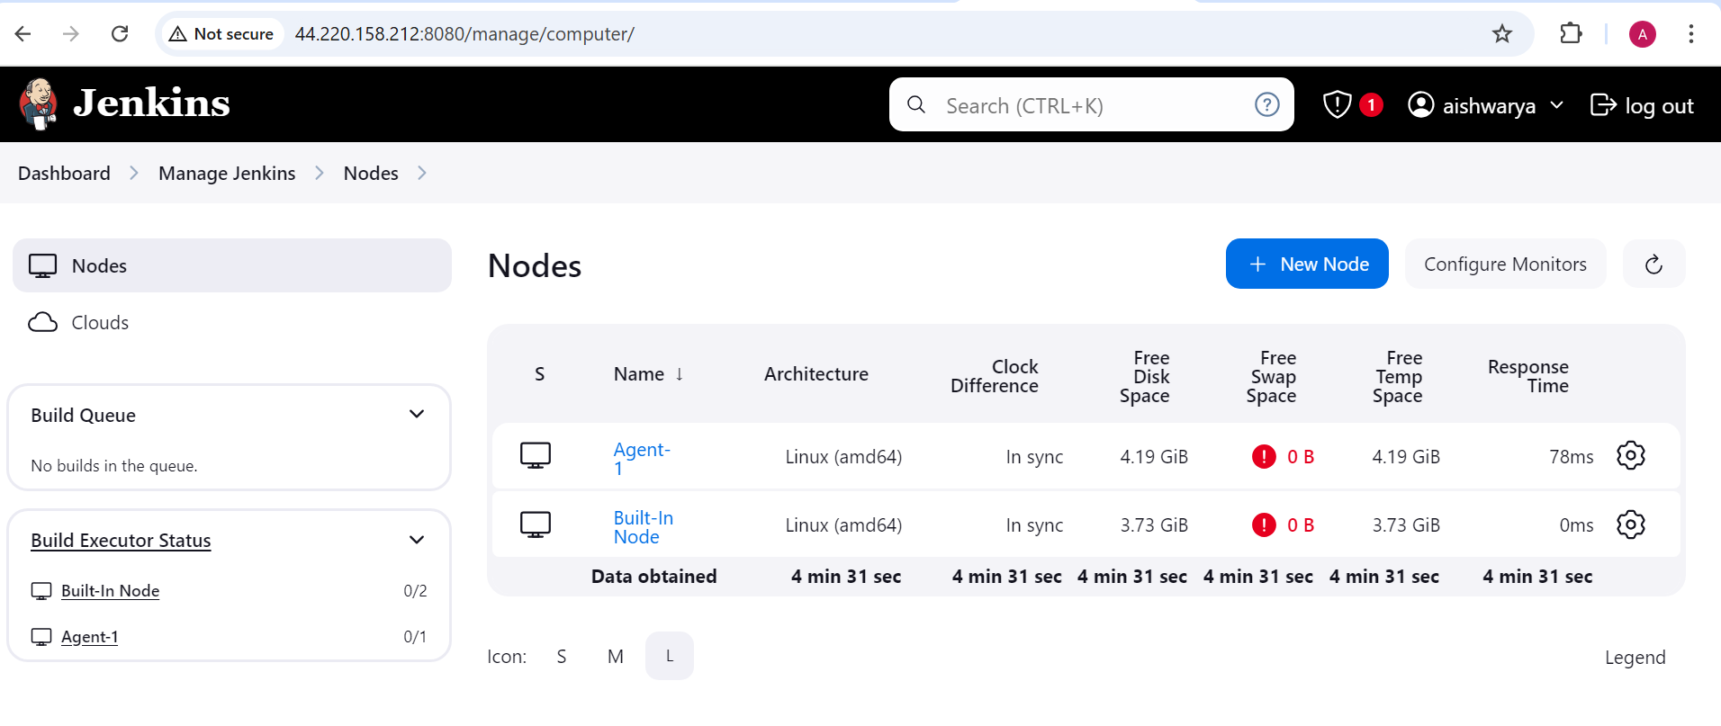

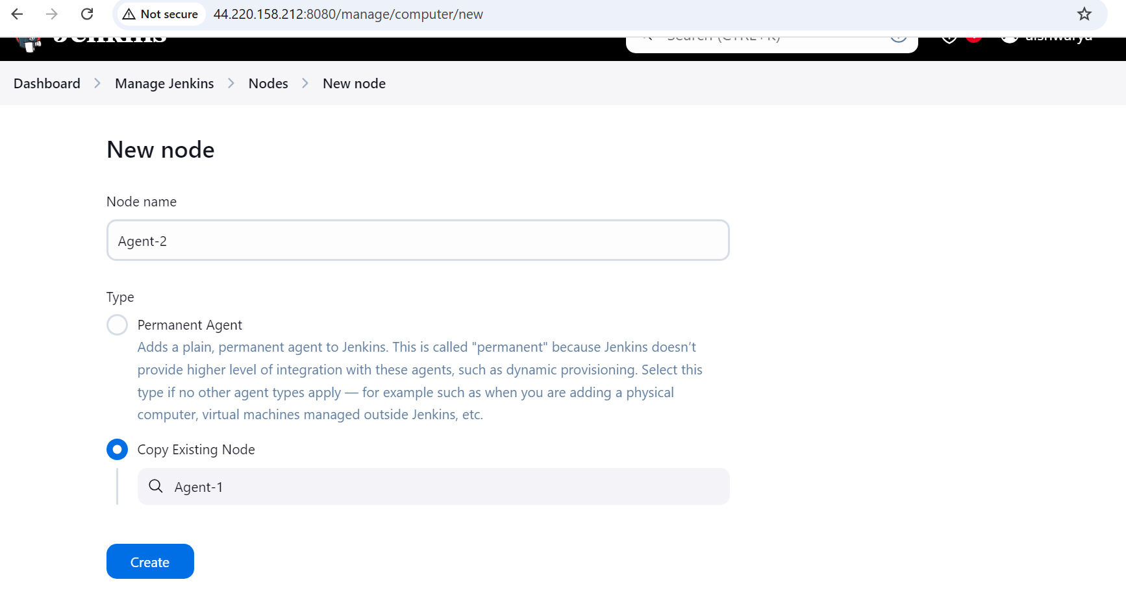

Change the host as private Ip of the slave2

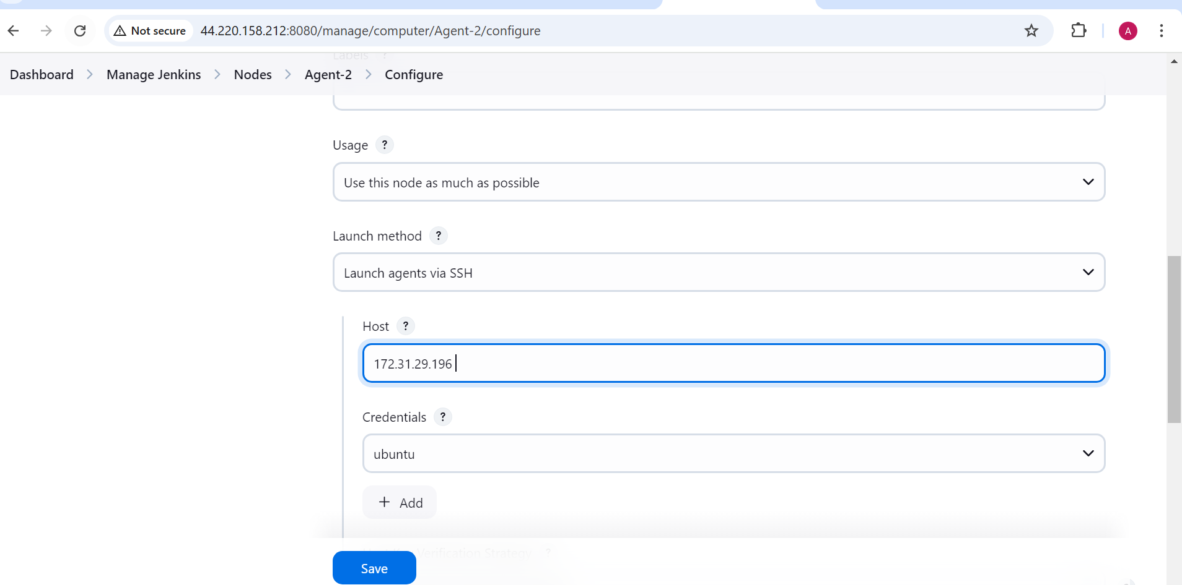

Node showing offline as we haven’t installed java on slave-2 so install java and try

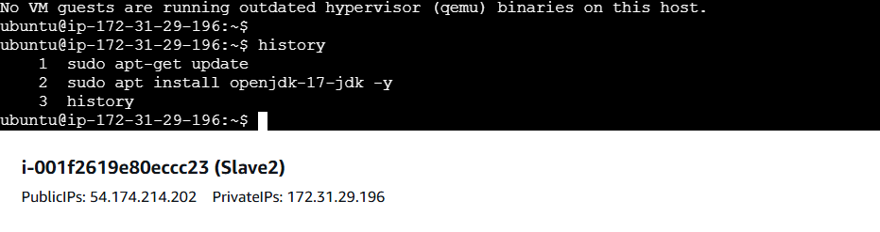

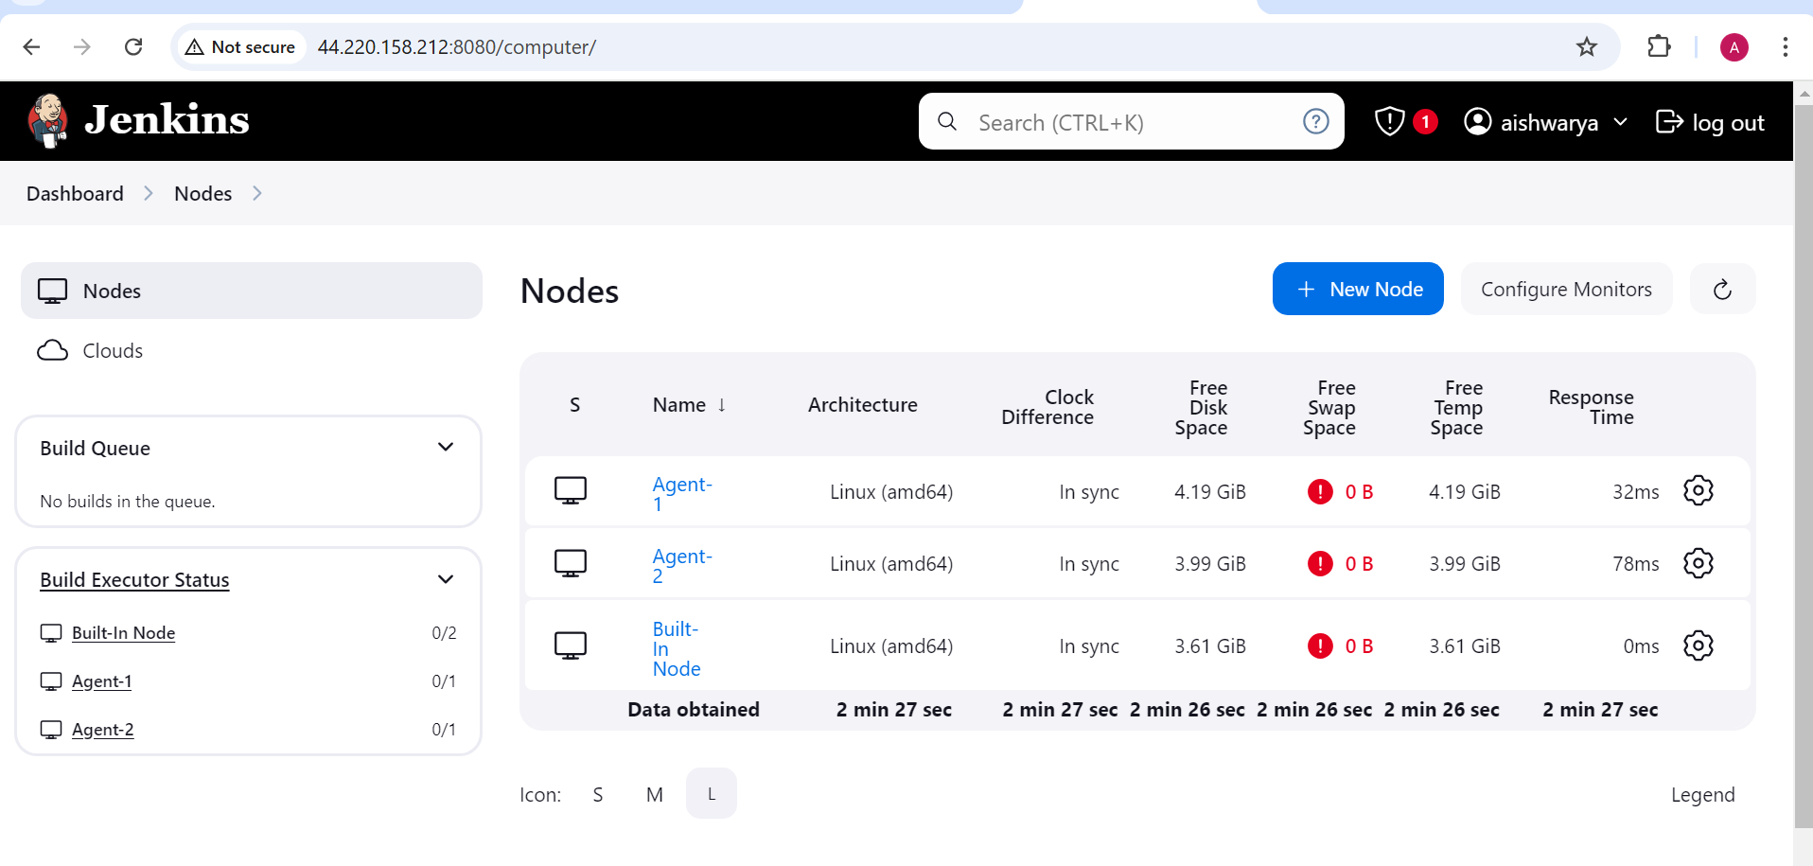

Create new job job2

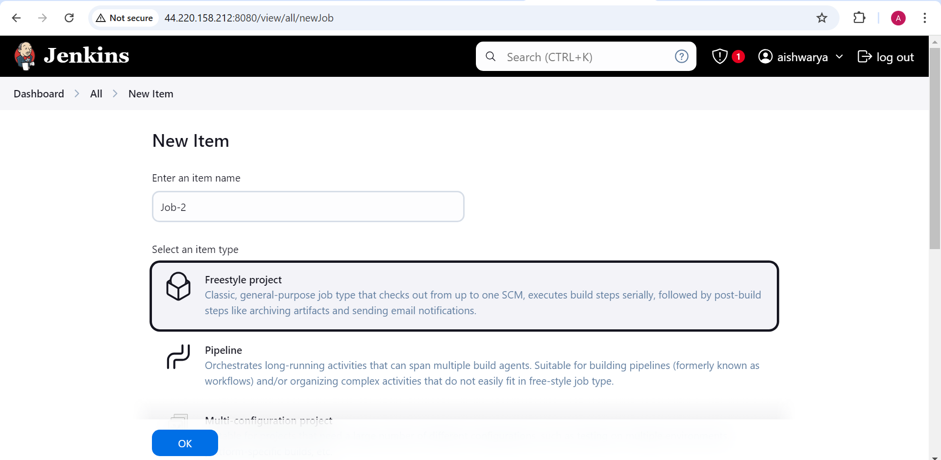

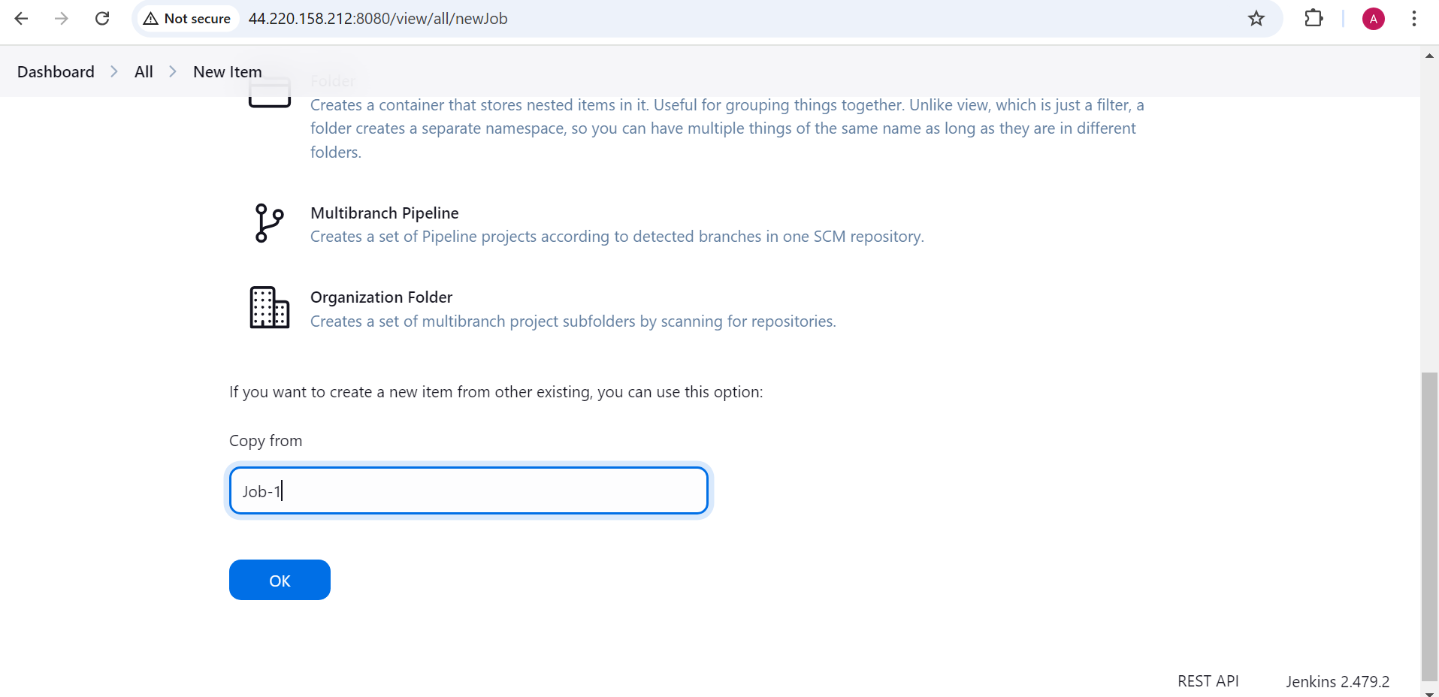

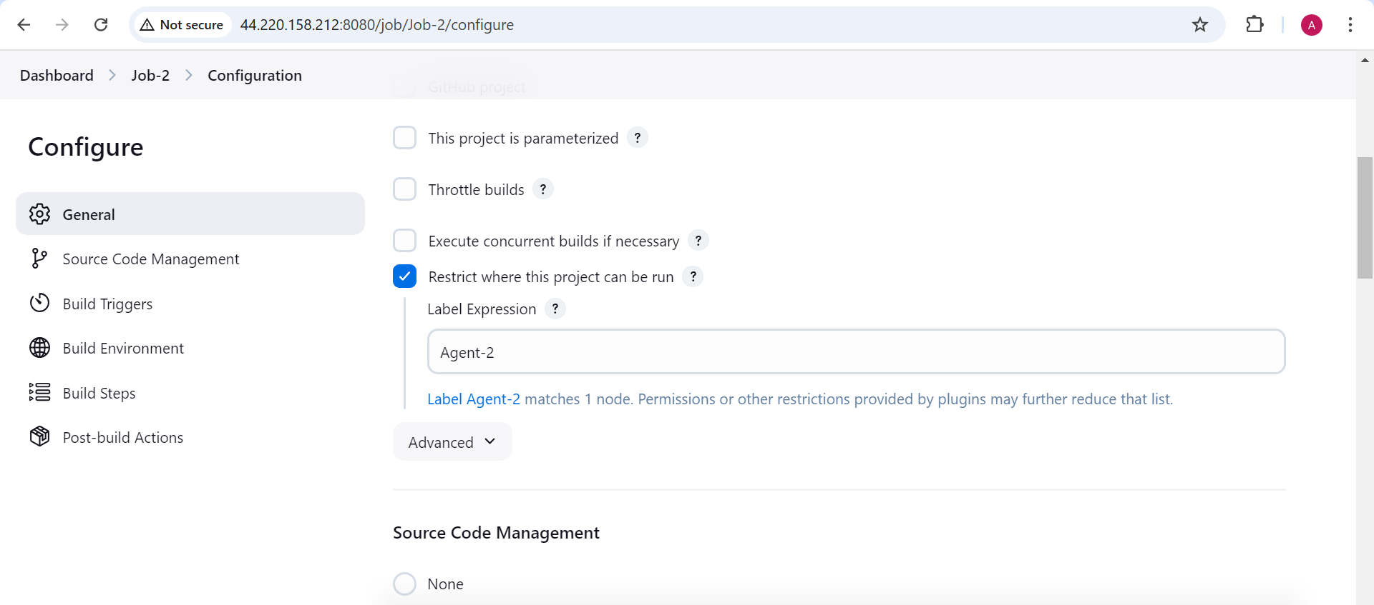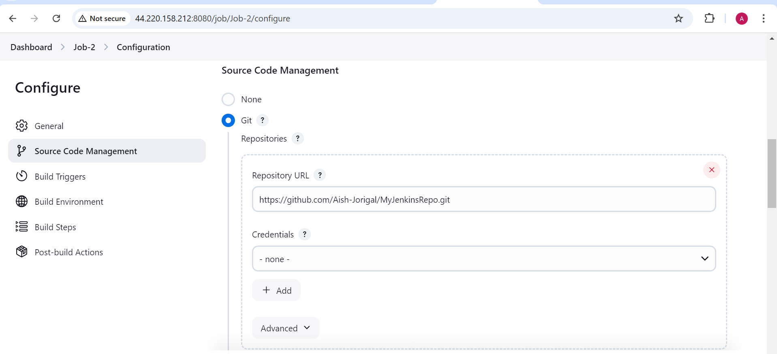

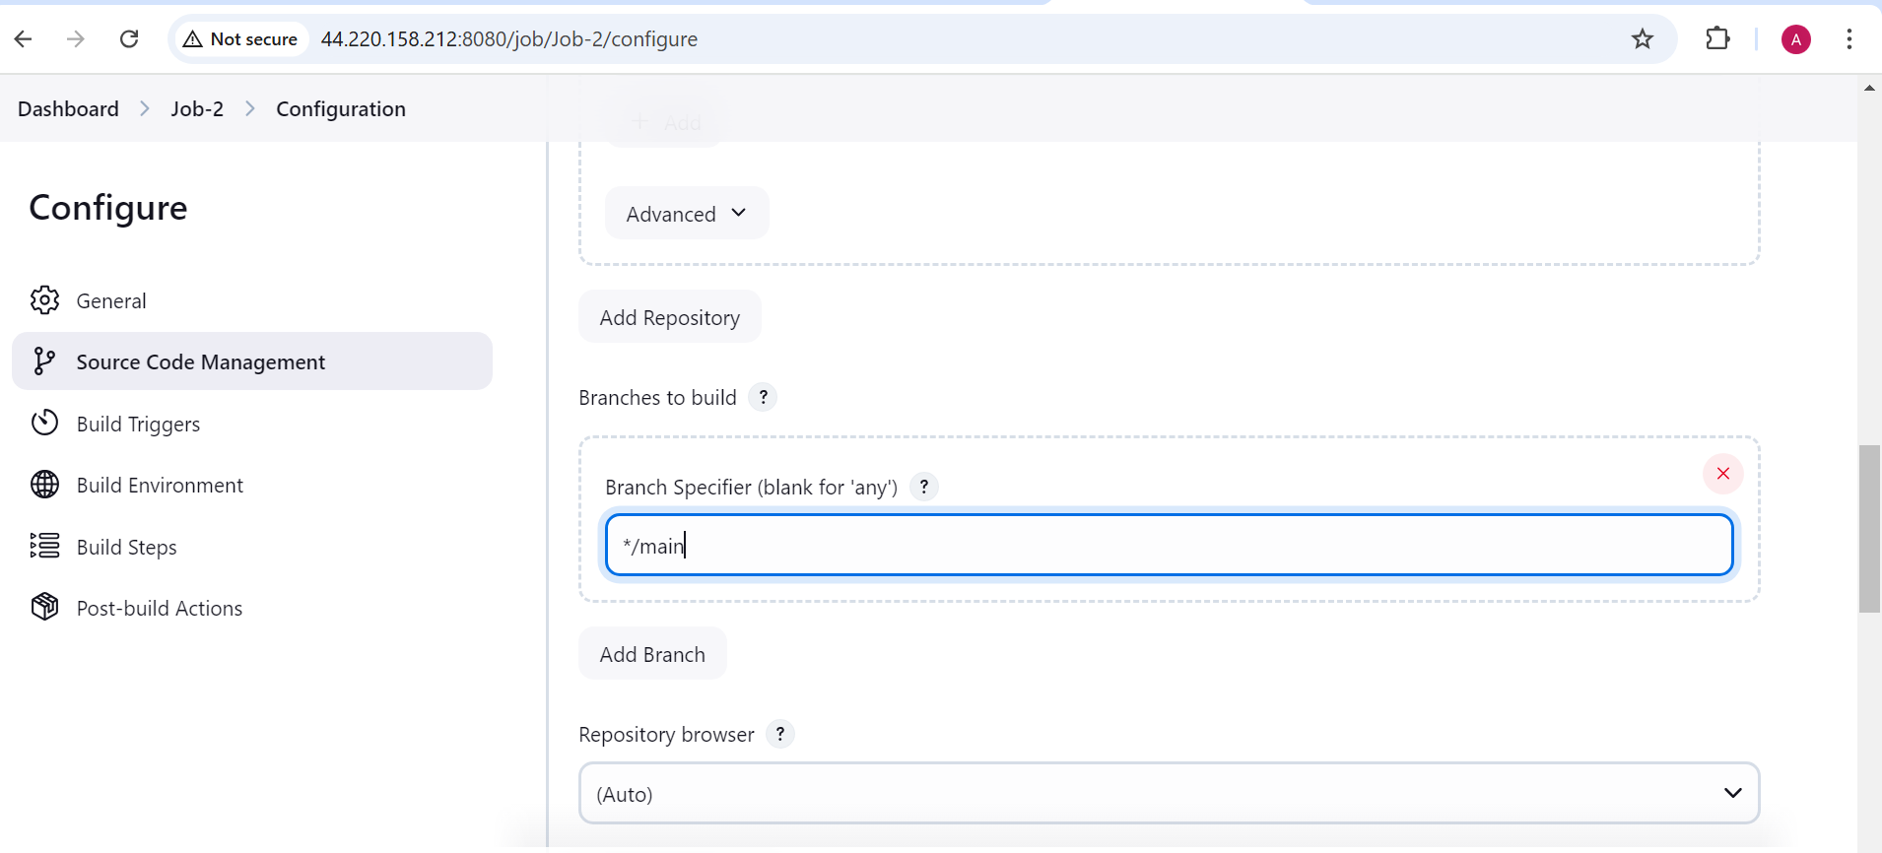

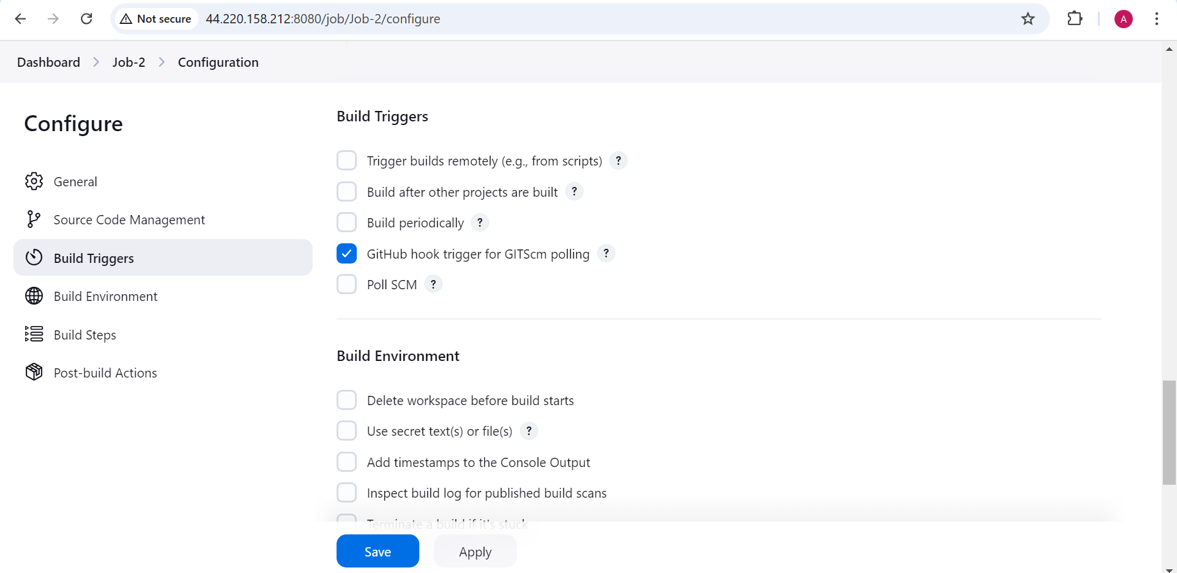

To test it:

Go to github account and do changes in the main branch and commit.

It will trigger this job2

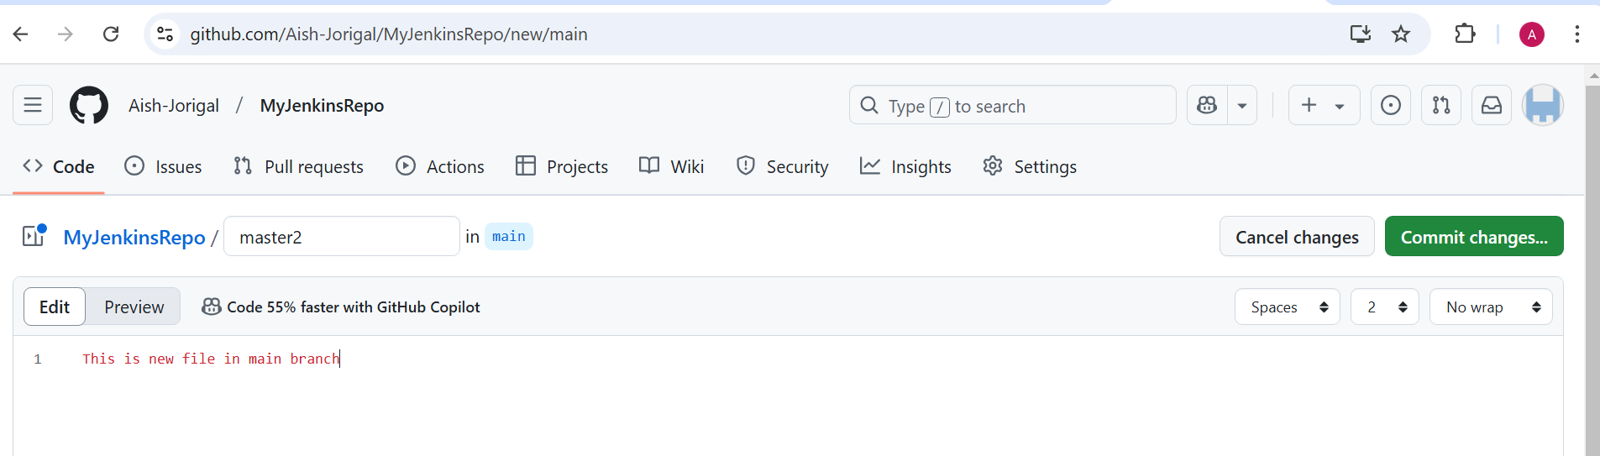

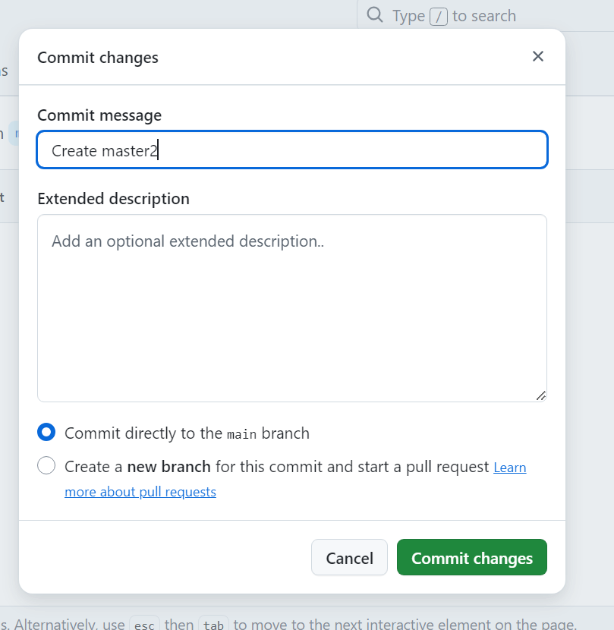

Trigger the job2

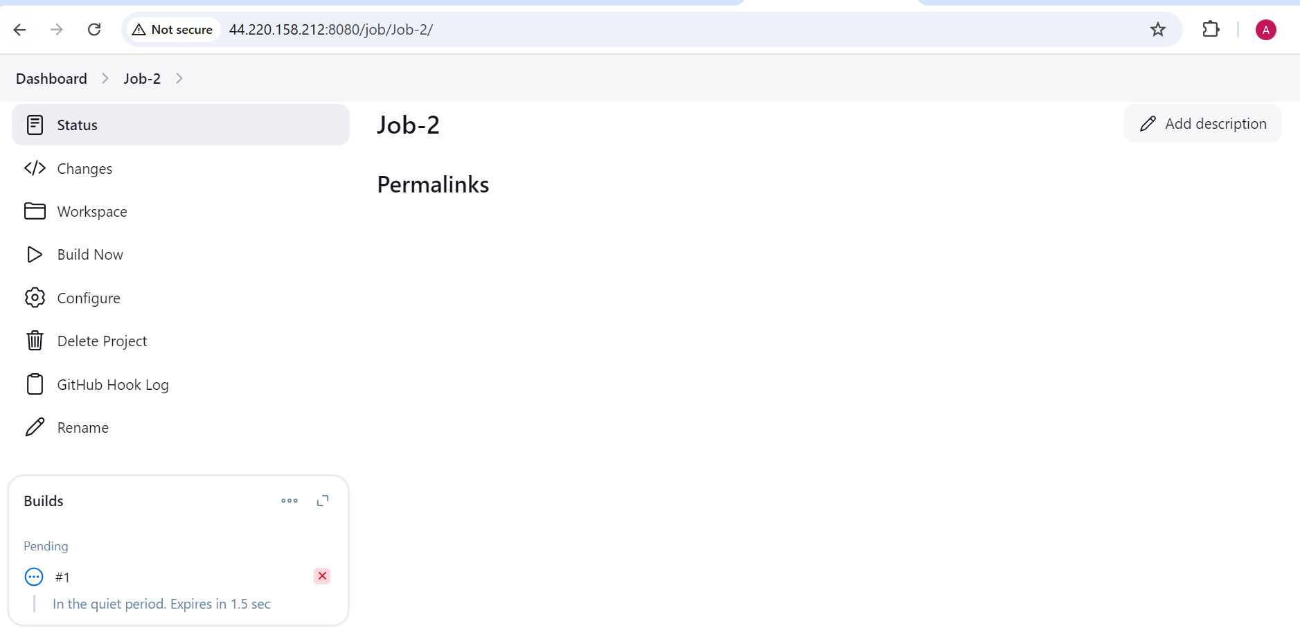

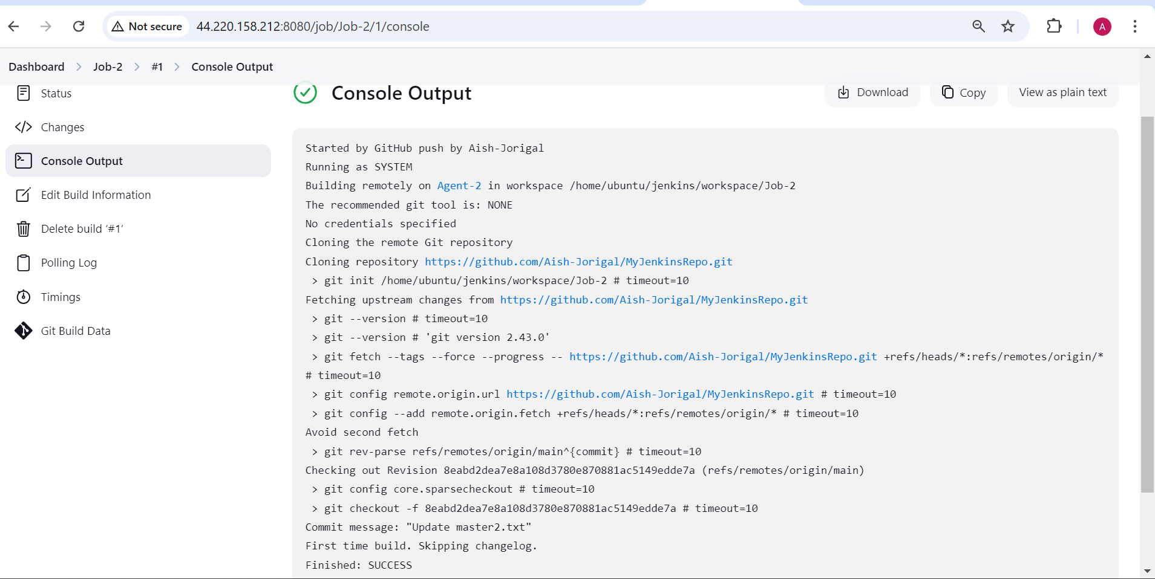

On slave 2 machine

